





LMETB Assessment Appeals Procedure: Process or Results
Arna chomhchistiú ag Rialtas na hÉireann agus ag an Aontas Eorpach.
Co-funded by the Government of Ireland and the European Union.
Policy Version Control
Policy Title | LMETB Assessment Appeals Procedure: Process or Results
Policy Reference No.
Original Creation Date | June 2019
Version Number | V3
Version Author | QAES
Version Update History | June 2019  V1 Reviewed, changes made and approved September 2021  V2 Reviewed, changes made and approved April 2024  V3 Reviewed, changes made and approved February 2026
Document Owner | QAES
Approved By | V3 Approved by QAGMC
Date Approved | 6/02/2026
Noted By | LMETB Board of Management
Dated Noted | 26/02/2026
Review Due Date | Annually from date of QAGMC Approval

LMETB Assessment Appeals Procedure: Process or Results
Purpose | To outline the rules governing appeals of assessments in QQI accredited courses for learners who wish to appeal on the grounds of either Process or Results.
Scope | This policy deals with learner appeals against assessment decisions on the grounds of either Process or Results.
Contents | - Assessment Process Appeals  Principles of Assessment  Programme Specific Requirements  Definitions  Assessment Appeals Roles and Responsibilities  - Assessment Result Appeals  Definitions  Assessment Appeals Roles and Responsibilities  Assessment Result Appeals Process  Appendix 1: Assessment Appeals Application Form  Appendix 2: Grounds for Appeals  Appendix 3: Assessment Appeals- Craft Apprenticeships
Related Policies | LMETB Assessment Deadlines Process  LMETB Assessment Repeats Policy
Audience & Communication | Applicable to all staff and learners of LMETB.  This procedure is available on the LMETB website.
Policy/Procedure Owner  & Implementation | Quality Assurance and Enhancement Service (QAES).
Monitoring, Evaluation & Continuous Improvement | Biennial.

Glossary of Terms
Term | Explanation
Appeals Examiner | The Appeals Examiner refers to the individual who examines the learner assessment appeal evidence and makes a decision on the appeal.  An Appeals Examiner is appointed by the ETB and is a person who MUST:  - Be a subject matter expert  - Be External to the original assessment process  - Have no conflict of interest with the learner or Learning Practitioner(s)  - Be external to the provider or to the original assessment process  Ideally, the Appeals Examiner should be an External Authenticator.
Assessment Appeals Facilitator | The Assessment Appeals Facilitator or designated person refers to the individual who facilitates the learner assessment appeal. The Assessment Appeals Facilitator must have a working knowledge of assessment and quality assurance procedures; ensure that no conflict of interest exists; and have had no prior involvement in the assessment processes relating to the particular piece of assessment.by which an authoritative body gives formal recognition that a body or person is competent to carry out specific tasks.
Centre | The Centre refers to any ETB College or ETB Education /Training Centre.
Centre Manager | The Centre Manager refers to the Centre Manager, Centre Director, Principal or the manager of any ETB College or ETB Education/Training Centre. In the event of the absence of a Centre Manager, an appropriate designated person should be assigned.
ETB | The Centre refers to any ETB College or ETB Education /Training Centre.
ETB Manager | The ETB Manager refers to any manager within the ETB.
Independent Appeals Committee | The Independent Appeals Committee refers to the committee which examines the assessment process appeals. The committee is appointed by the ETB and MUST:  - Consist of a minimum of two ETB senior personnel who are external to the Centre  - Have knowledge of QA procedures  The independent Appeals Committee should be supported by internal QA personnel.  Depending on the nature of the appeal, personnel from outside the ETB may be required. This is at the discretion of the ETB.
Invigilator | The Invigilator refers to the individual who supervises an examination.  Ideally, an alternative invigilator other than the Learning Practitioner should supervise an examination.  The Invigilator (appointed by the Programme Co-ordinator) must:  - sign a declaration of impartiality  - Be appointed in line with the specific guidelines of the awarding body, if such guidelines exist.
Learning Practitioner | The Learning Practitioner term refers to all teaching staff and includes teachers, tutors, lecturers, instructors, educators, facilitators etc.
Programme Co-ordinator | The Programme Co-ordinator refers to Programme Co-ordinator, Programme Manager or other relevant manager of course or programme. In the event of the absence of a Programme Manager, an appropriate designated person should be assigned.
RPL Mentor/Facilitator | The RPL Mentor/Facilitator refers to an individual who:  - is familiar with RPL policies  - has received training in RPL  - is a subject matter expert

Assessment Process Appeals

Principles of Assessment in relation to Assessment Process Appeals
Quality assured assessment ensures that in criterion referenced assessment “learners are assessed and the assessment judgement is made based on whether the learner has reached the required national standard of knowledge, skills and competence for the award” (QQI, Revised 2018 p.5). Central to quality assured assessment is the assumption that learners are assessed in a fair and consistent manner in line with the award standard. Quality assured assessment ensures adherence to the principles of assessment.
The following sets forth the principles of assessment which apply to this document: these principles are based on the QQI (Revised 2018) principles for assessment.

Validity
Validity is a fundamental assessment principle ensuring that an assessment measures what it is designed to measure: the relevant standard of knowledge, skill or competence required for an award should be assessed.
Validity in assessment occurs when:
- Assessment is fit for purpose (i.e. a practical assessment assesses practical skill)
- Learners can produce evidence which can be measured against the award standard
- Assessors can make accurate assessment decisions
- Assessment is accessible to all candidates who are potentially able to achieve it.

Reliability

Reliability in assessment ensures that assessment measurement is accurate: the knowledge, skills and competence which the assessment measures should produce reliable and accurate results.
Reliability in assessment ensures that results are consistent under similar conditions.
Reliability in assessment occurs when:
- The assessment is based on valid assessment techniques
- Assessment conditions are consistent
- Learner evidence is reliable
- Results are consistent across various assessors, contexts, conditions and learners over time.

Fair
Fairness in assessment supports the validity and reliability principles and provides equal opportunity to all learners. Fairness in assessment ensures learners have access to appropriate resources/equipment in assessment; assessment design and implementation are fair to all learners; and policies and procedures exist to ensure fair assessment of learners.

Quality
Quality in assessment ensures that all assessment processes are quality assured.

Transparency
Transparency in assessment ensures that assessment policy and procedures provide clarity to all relevant stakeholders. Based on QQI Principles for Assessment (QQI, Revised 2018)
Learners have the right to appeal the assessment process within a specified timeframe. In order to ensure adherence to the principles of assessment, the following process should be followed in relation to ASSESSMENT PROCESS appeals. For ASSESSMENT RESULT appeals please see p.10 of this procedure document. This will thus ensure that assessment is fair for all learners along with being reliable and consistent across LMETB’s programmes and modules.

Programme specific requirements
Some programmes, such as Craft-based Apprenticeships have programme-specific requirements which supersede those outlined in the main body of this LMETB Appeals Policy/Procedure document. Specifically in the case of Craft based Apprenticeships, these requirements are detailed in Appendix 3 of this document.

Assessment Process Appeal
An assessment process appeal refers to the appeal by a learner to the provider based on the assessment conditions and/or process: the learner believes the assessment conditions and/or process negatively impacted his/her assessment performance.

Assessment Results Appeal
An assessment result appeal refers to the appeal of an approved result. In such cases, the learner is not satisfied with their assessment result: the learner believes the marks awarded are not representative of the quality of the work submitted for assessment.
Only approved results of work submitted can be formally appealed by the learner. No new assessment evidence can be submitted.
appeal by a learner to the provider based on the assessment conditions and/or process: the learner believes the assessment conditions and/or process negatively impacted his/her assessment performance.

Definitions

Approved Results
Approved results are results which have been through the internal verification and external authentication process and been approved for distribution to learners by the Results Approval Panel. An appeal can only be made based on approved results.
Assessment Process Appeal
An assessment process appeal refers to the appeal by a learner to the provider based on the assessment conditions and/or process: the learner believes the assessment conditions and/or process negatively impacted his/her assessment performance.

Timeframe for lodging an assessment process appeal
Assessment process appeals should be made within 1 (one) week of the issuing of approved results.

Assessment Appeals Roles and Responsibilities

Ideally, learner complaints relating to the assessment process, and their immediate reporting to a relevant staff member, should be both encouraged and facilitated during the programme. It is expected that most learner complaints in relation to the assessment process can be addressed internally by the centre. It may be appropriate to allow learners to view their assessment material before a decision to appeal is made or not by the learner. It will be necessary for centres to document formal complaints. In the event of an assessment process appeal by the learner to LMETB, the Independent Appeals Committee will request any centre records that pertain to the learner’s appeal.

The Programme/Centre Co-ordinator/Designated Person
The Programme/Centre Co-ordinator/Designated Person must:
  - Ensure that all learners are made aware of:
    - the grounds for making an appeal (assessment result appeal or assessment process appeal, see p.18 for more information on the grounds for appeal).
    - the maximum time allowed to lodge an appeal.
  - Communicate the deadline date for requesting an appeal to the learner (1 week after issue of approved results). Learners may not appeal after this date.
  - Receive the appeal application from the learner.
  - Submit Assessment Appeals Application Form to the Independent Appeals Committee.
  - Inform the awarding body of the result change (if successful).
  - Inform the learner of the outcome of the appeals application.

The Learner
If a learner wishes to appeal an assessment process, the learner must:
- Note the grounds for appeal (assessment process appeal application, see p.18 for more information on the grounds for appeal)
- Note the grounds for appeal
- Note the timeframe for appeal (within 1 (one) week of results)
- Lodge an appeal (with fee if applicable) by completing the Assessment Appeals Application Form
The Independent Appeals Committee
The Independent Appels Committee must:
- Examine the learner appeal
- Investigate whether relevant assessment procedures were followed
- Make a decision on the appeal

Assessment Process Appeals
Note:
- The learner is notified by the Centre of the deadline for appeals within the given assessment period.
- LMETB will endeavour to complete all appeals within twenty (20) working days on receipt of appeal. Every effort should be made to process the application as promptly as possible, especially if CAO/other deadlines may be impacted.
Where possible, the learner discusses the appeal application with the Learning Practitioner and/or Programme/Centre Co- ordinator/Designated Person and examines grounds for appeal and timeframe before proceeding.
The following process outlines the steps involved in an assessment process appeal. PLEASE NOT THAT THE APPEAL RESULT IS FINAL.

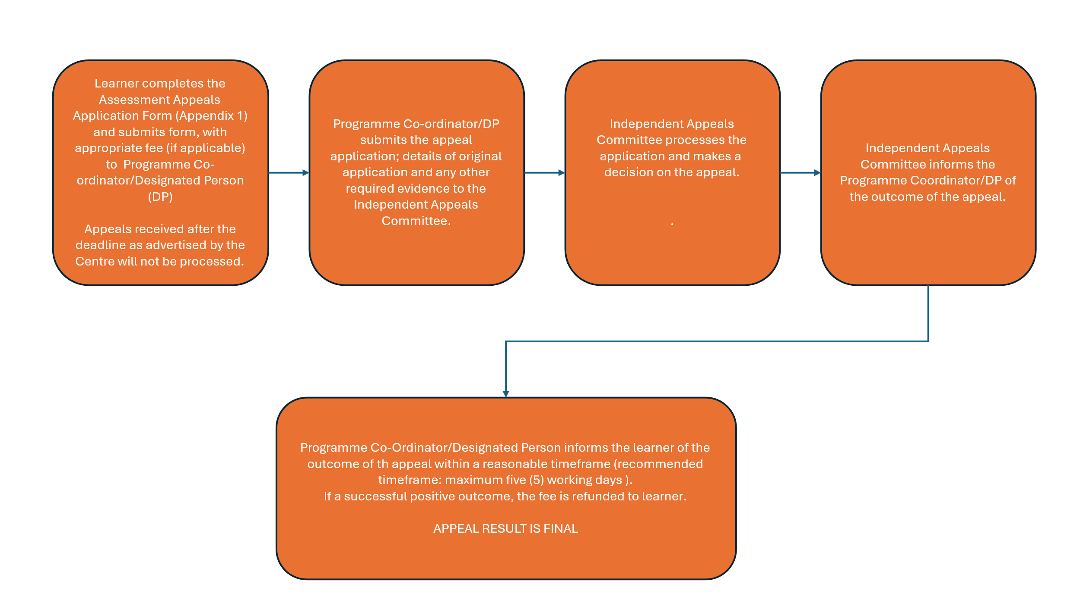

References

QQI (Revised) Quality Assuring Assessment Interim Guidelines for Providers 2025.
QQI. Available from: Quality Assuring Assessment Interim Guidelines for Providers

Assessment Result Appeals

Definitions

Approved Results
Approved results are results which have been through the internal verification and external authentication process and been approved for distribution to learners by the Results Approval Panel. An appeal can only be made based on approved results.

Assessment Result Appeal
An assessment result appeal refers to the appeal of an approved result. In such cases, the learner is not satisfied with their assessment result: the learner believes the marks awarded are not representative of the quality of the work submitted for assessment.
Only approved results of work submitted can be formally appealed by the learner. No new assessment evidence can be submitted.
are results which have been through the internal verification and external authentication process and been approved for distribution to learners by the Results Approval Panel. An appeal can only be made based on approved results.

Timeframe for lodging an assessment process appeal
Assessment process appeals should be made within 1 (one) week of the issuing of approved results.

Assessment Result Appeals Roles and Responsibilities

The Programme/Centre Co-ordinator/Designated Person
The Programme Co-ordinator must:
  - Ensure that all learners are made aware of:
    - the grounds for making an appeal (assessment result appeal or assessment process appeal, see p.18 for more information on the grounds for appeal).
    - the maximum time allowed to lodge an appeal.
  - Communicate the deadline date for requesting an appeal to the learner (1 week after issue of approved results). Learners may not appeal after this date.
  - Receive the appeal application from the learner.
  - Submit the Assessment Appeals Application Form to the Assessment Appeals Facilitator.
  - Inform the awarding body of the result change (if successful).
  - Inform the learner of the outcome of the appeals application.

The Learner
If a learner wishes to appeal an assessment result(s), the learner must:
  - Note the grounds for appeal (assessment result appeal application, see p.18 for more information on the grounds for appeal)
  - Note the timeframe for appeal (within 1 (one) week of issue of approved
results)
  - Lodge an appeal (with fee if applicable) by completing the Assessment Appeals Application Form
Only assessment evidence that has already been submitted as part of the final assessment can be considered as part of an appeal: no new evidence can be submitted.

The Assessment Appeals Facilitator:
The Assessment Appeals Facilitator must:
  - Ensure that all documentation is available for the appeal (completed appeals form, learner evidence etc.)
  - Assign an Appeals Examiner
  - Receive the decision of Appeals Examiner
  - Inform the awarding body of the result change (if successful)
  - Report appeal outcome decision to the Programme Co-ordinator.

The Appeals Examiner:
An Appeals Examiner must:
  - Examine the Assessment result appeal application and learner assessment evidence
  - Make a decision regarding the appeal
  - Report appeal outcome decision to the Assessment Appeals Facilitator

Assessment Result Appeals Process
Note:
- The learner is notified by the centre of the deadline for appeals within the given assessment period.
- LMETB will endeavour to complete all appeals within twenty (20) working days on receipt of appeal. Every effort should be made to process the application as promptly as possible, especially if CAO/other deadlines may be impacted.
Where possible, the learner discusses the appeal application with the Learning Practitioner and/or Programme Co-ordinator and examines grounds for appeal and timeframe before proceeding

Only approved results can be formally appealed: no new assessment evidence can be submitted.
The following process outlines the steps involved in an Assessment Result appeal.
  - Learner completes the Assessment Appeals Application Form and submits form to Programme/Centre Co-ordinator/Designated Person (DP) together with the appeals fee (if applicable)
  - Programme/Centre Co-ordinator/DP submits application to Assessment Appeals Facilitator. All assessment evidence, as required by the component specification/validated programme or module, must be available for the appeal. Any evidence not available will be assumed not to have been completed or submitted.
  - Assessment Appeals Facilitator processes the application and:
- Assigns an Appeals Examiner
- Will endeavour to complete all appeals within twenty (20) days on receipt of appeal. Every effort should be made to process the application as promptly as possible, especially if CAO/other deadlines may be impacted.
  - Assessment Appeals Examiner makes a decision on the appeal and informs the Assessment Appeals Facilitator. The Assessment Appeals Examiner completes a:
- Totting/recording check for any errors. If an error is found, marks are changed.
- Review of the assessment evidence and makes a decision as to whether grades are upheld or changed.
Makes a decision on the appeal and informs the Assessment Appeals Facilitator of the outcome.
  - Assessment Appeals Facilitator informs the Programme/Centre Co-ordinator/DP of the outcome of the appeal (successful or unsuccessful) within a reasonable timeframe (recommended timeframe: maximum two (2) working days).
  - If successful, the Assessment Appeals Facilitator or Programme Coordinator informs the awarding body of the change.
  - Programme Co-ordinator or designated person, informs the learner of the outcome of the appeal within 5 working days. Where applicable, the fee is refunded to the learner.
  - At the next Results Approval Meeting, all appeal results from previous assessment period are ratified.
The appeal result is final.

The following process outlines the steps involved in an Assessment Result appeal.
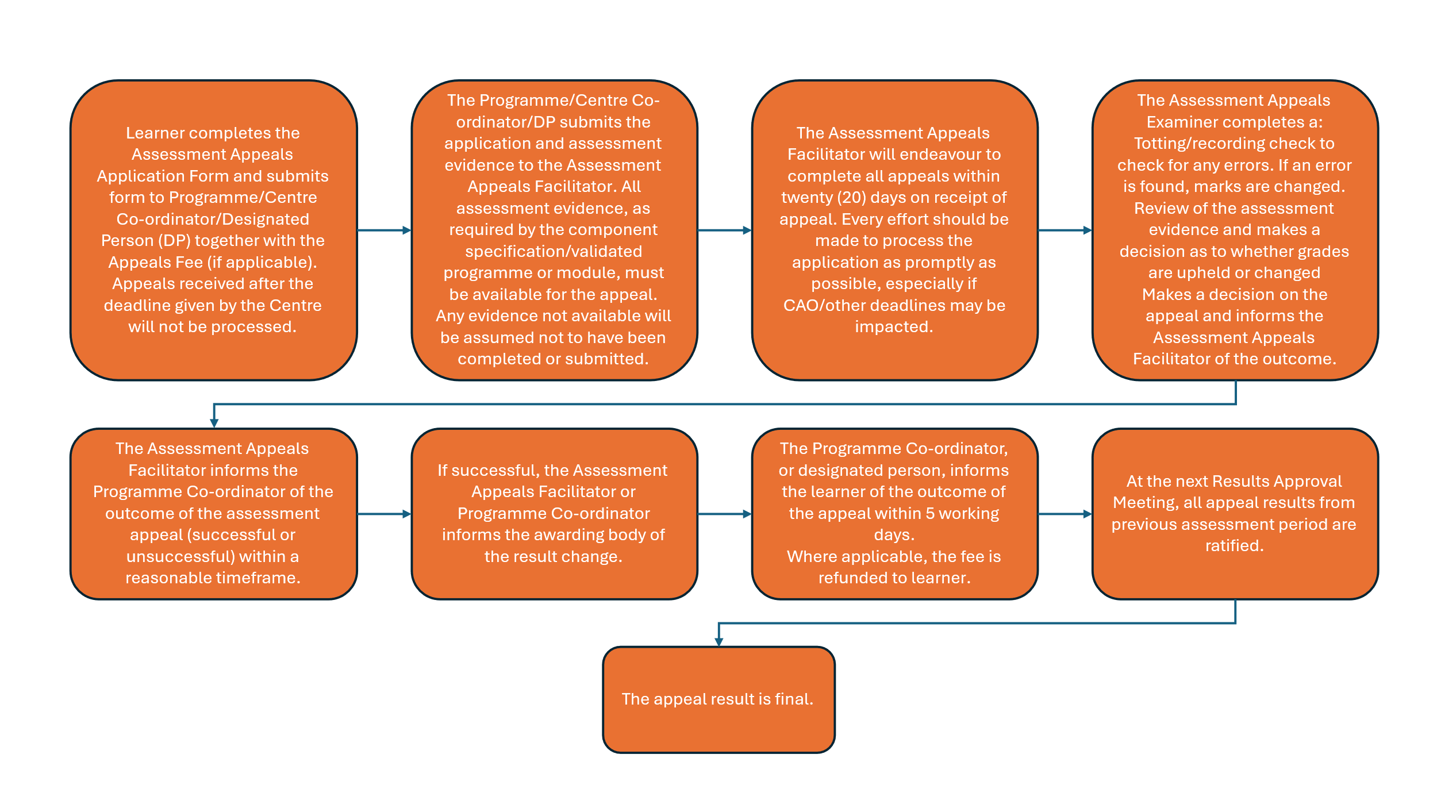

References

QQI (Revised) Quality Assuring Assessment Interim Guidelines for Providers 2025.
QQI. Available from: Quality Assuring Assessment Interim Guidelines for Providers

Appendix 1: Assessment Appeals Application Form
Part A: To be completed by the learner and returned to the Programme /Centre Co-ordinator/Designated Person (DP) by a specified deadline
Please indicate which appeal you are requesting
Assessment Result Appeal
To be used only when appealing the results of your assessment.
Assessment Process Appeal
To be used only if you believe the assessment conditions are/or process negatively impacted your assessment performance.
Centre Name:
Learner Name:
Learner Email/Contact Number:
Programme Code/Title:
Are there any impending deadlines which may need to be considered with this application: CAO Application/Other Applicant: Yes/No

Please note: If you have applied to the CAO, please check with your FET Centre for the last date for appeal submissions. Appeals received after this date may not be considered by the CAO for the purpose of offers.
Please give details of any deadlines here:

Details of application – Please explain why you are appealing your result:

Module Code | Module Title | Module Level | Original Result | Grounds for Appeal (See Table 1.1) | Fee
 |  |  |  | Total Fee €

Candidates wishing to appeal their final result must complete this form and return to the Programme Co-ordinator, (Insert name and address of centre here ), on or before xx/xx/xx. Appeals received after this date will not be processed.

There is an administrative fee of €50* per module result that you wish to appeal. This fee must be made payable to [Insert name of Centre here]. Fee should be paid by EFT, cheque, postal order or bank draft. NO CASH. The outcome of the Appeal will be communicated directly to you in xx. If successful, the administrative fee of €50 per module will be refunded.

Appeals will not be processed without payment of fee.
Please note: There is no appeal fee for Craft Apprenticeship programmes for the first three attempts. An administration fee of £50 made payable to LMETB shall apply for a fourth attempt. For all other non-Craft Apprenticeships, please check the appeals fee with your Apprenticeship Provider or Centre.

I can confirm that I have read and understand the appeals procedure including the grounds for appeal. I can confirm that I have enclosed a total fee of € . This fee is refundable if the appeal is successful.
Learners Signature: Date:
Programme Coordinator Signature: Date:
Part B: To be completed by the Programme Co-ordinator and forwarded to the Assessment Appeals Facilitator.
Centre Name:
Centre Contact Name:
Centre Contact Email Address:

Learner Name:
External Authenticator:
Fee Paid: | Yes/No
Assessment Appeals Facilitator

Signature:

Date Received:

Appeals Examiner Signature:
Date Received:
Appeal Decision | Appeal Successful/Unsuccessful
Details of appeal investigation

Details of designated person to communicate outcome of appeal to learner.

Appendix 2: Grounds for Appeals
Learners may lodge an appeal if they are not satisfied with the grade awarded and/or if they perceive that there was an irregularity within the assessment process itself.
An Assessment Process Appeal is where the learner believes that the assessment did not comply with LMETB’s assessment conditions, specifications or procedures and that the learner’s assessment performance was negatively impacted as a result.
Learners may submit an appeal of the assessment process under the following areas of assessment:
- communications and information – insufficient notice or information was provided to the learner in relation to the assessment
- planning and design – the assessment did not assess what it claimed to assess, or the format was not as outlined in the award descriptor
- conducting and implementing an assessment event – the assessment regulations were not properly implemented
- deadlines
- compassionate consideration – approved compassionate circumstances were not considered
- reasonable accommodation
- security of the assessment materials, records and documentation
- feedback to learners
- malpractice
- marking and grading
- repeats
- internal verification and authentication process
- appeals process
- results approval process
An Assessment Result Appeal is where the learner believes that the marks awarded are not representative of the quality of the work submitted. Only approved results can be appealed by the learner. No new assessment evidence can be submitted. The learner portfolio of evidence will be sent to an independent Appeals Examiner for review.

Appendix 3: Assessment Appeals – Craft Apprenticeships

To facilitate the SOLAS Craft-based Apprenticeships, the LMETB Assessment Appeals procedure and the LMETB Assessment Repeats policy allows for up to three assessment attempts and an appeal of a referred Assessment Result, based on:
- Apprentice believes that assessment results were recorded inaccurately (recheck)
- Apprentice believes that assessment was marked inappropriately (review)
- The assessment rules were not properly implemented
- Assessment conditions did not comply with the brief. An appeal on these grounds will be considered if the apprentice has reported the situation to the Assessor during or immediately after the test. This will be documented in the Assessor’s report.
- The rules did not adequately cover the apprentice’s circumstances
- Compassionate or medical circumstances existed which were not taken into account
- Circumstances existed that may not have been covered by the assessment rules
- The apprentice believes that significant performance-related information was not considered by the assessor
- New information becomes available that was not available to the original assessor
- There is evidence of irregularity in the conduct of the assessment, which might have affected its outcome

The LMETB policies and procedures pertaining to the appeal of assessments (Results & Process) address the requirements as set out in The Craft Apprenticeship Assessment Rules (Solas 2023).
Apprentices wishing to appeal a result must complete the LMETB Assessment Appeal Application form in full, sign and return to the Apprenticeship Training Centre Manager or his/her nominee within 7 days of receiving their approved result. Appeals received after this deadline will not be processed.
Should an appeal of a third attempt be deemed to be unsuccessful by the LMETB assessment appeals committee (i.e. where local appeals processes have been exhausted), then a request for a fourth attempt can be made to the SOLAS National Apprenticeship Advisory Committee (NAAC) Sub-Group – The Appeals and Recognition of Prior Learning Committee, for their consideration.
One of the functions of the Appeals and Recognition of Prior Learning Committee within the National Craft Apprenticeship Framework is to adjudicate on appeal applications for a fourth attempt of referred assessment. It is the final adjudication body in relation to appeal applications and may consider any appeal which it considers reasonable, with the exception of issues related to the marking of assessments.
The SOLAS craft Apprenticeship Appeal application Form with accompanying supporting documentation should be filled out and returned to local SOLAS Authorised Officer (Senior Training advisor). An administration fee of €50 made payable to LMETB shall apply for the appeal. The form is available from the SOLAS Authorised officer (Senior Training advisor).
Contact apprenticeshipappeals@solas.ie for further information if required.

Definitions & References
(Relevant sections extracted from The Craft Apprenticeship Assessment Rules 2023 SOLAS)
11 Repeats, Re-sits, Re-checks, Reviews, and Referrals:
Collaborating providers must have in place policies and procedures pertaining to the repeat, re-sit, re-check, review and referral of assessments. Under the Labour Services Act 1987 - Apprenticeship Rules 1994 apprentices may attempt each off-the-job assessment three times. The apprentice can request that the result be rechecked, reviewed and appealed to the relevant collaborating providers on each occasion. Thereafter, if the failure of the assessment has been confirmed by the relevant training provider on the third and final occasion, the apprenticeship shall be automatically terminated (Apprenticeship Code of Practice for Employers and Apprentices, p.9).

Definition of an attempt: An apprentice entering the examination hall or venue is required to sign an attendance sheet (register). Any apprentice who is registered and admitted to the examination hall or venue for the purpose of undertaking an assessment is deemed to have attempted an assessment. Non-attendance by any apprentice registered to sit an assessment without a reasonable explanation will be deemed to have attempted an assessment. Apprentices should be facilitated in receiving feedback on their assessment, including the opportunity to view their marking scheme in a timely, accurate, transparent and constructive manner. Collaborating providers should advise apprentices on the policies and procedures relating to repeats, re-sits, rechecks, reviews, referrals and appeals prior to assessment. Repeats, re-sits and referrals should be conducted in the same conditions as the original assessment. SOLAS should be notified of any change in status using examination result transfer procedures.
Below are the options available to apprentices who do not reach pass standards on an assessment.
11.1 Repeats are classed as 2nd or 3rd attempts: They must take place a minimum of 5 days after the initial attempt. An equivalent assessment is selected by the coordinating provider, where applicable. Apprentices may appeal to the SOLAS Apprenticeship Appeal Committee to request a 4th attempt.
Please see the Craft Apprenticeship Quality Assurance Manual and the Apprenticeship Guideline 106 for more detail.
11.2 Re-sit: A re-sit is an opportunity to retake an assessment which had to be abandoned due to sickness or emergency. An equivalent assessment is selected by the coordinating provider, where applicable
11.3 Re-check: An apprentice can request a recheck if they believe their results were recorded inaccurately.
11.4 Review: An apprentice can request a review if they believe their assessment was marked inappropriately.
11.5 Referral: An apprentice is referred if they fail to reach the pass grade of 50% in and are eligible for a repeat. Such effort will be counted as an attempt.
11.6 Online Assessments In the event of an online assessment having an issue arising relating to any of the above circumstances which is outside the remit of the collaborating provider, the provider should contact SOLAS Apprenticeship Services Unit via examsoffice@solas.ie
12 Non-attendance and Deferrals Collaborating providers must have in place, policies and procedures pertaining to non attendance, and deferrals.
13 Appeal of Assessment Results
Collaborating providers must have in place, policies and procedures pertaining to the appeal of assessments. All processes should be documented and the documentation retained in line with section 16 (of The Craft Apprenticeship Assessment Rules Solas 2023 ). SOLAS should be notified of any change in status using examination result transfer procedures. Apprentices who are unsuccessful in their appeals must be made aware of the mechanisms by which the appeal can be escalated.

13.1 Circumstances for Appeal
Appeals should be facilitated in the following circumstances:
- Apprentice believes that assessment results were recorded inaccurately (recheck)
- Apprentice believes that assessment was marked inappropriately (review)
- The assessment rules were not properly implemented
- Assessment conditions did not comply with the brief. An appeal on these grounds will be considered if the apprentice has reported the situation to the Assessor during or immediately after the test. This will be documented in the Assessor’s report.
- The rules did not adequately cover the apprentice’s circumstances
- Compassionate or medical circumstances existed which were not taken into account
- Circumstances existed that may not have been covered by the assessment rules
- The apprentice believes that significant performance-related information was not considered by the assessor
- New information becomes available that was not available to the original assessor
- There is evidence of irregularity in the conduct of the assessment, which might have affected its outcome.
13.2 On-the-Job Appeal Apprentices wishing to appeal an on-the-job assessment result may initially raise their concerns with their employer assessor and/or verifier. They may also raise their concerns with the SOLAS Authorised Officer/ Senior Training Advisor and request an appeal of the recorded assessment result.

Issue Number | Effective Date | Amendments | Reason for Amendments
V3 | 03/2026 | Amendments made to appeals fee. Addition to policy to include Craft Apprenticeships. | Amendments made to appeals fee. Addition to policy to include reference to Craft Apprenticeships.

This role may be completed by the Assessment Appeals Facilitator
This role may be completed by the Programme Co-ordinator
Appeal Fee only applicable for appeal of results: this fee is refunded if appeal is successful
The current on the job appeal policy is an interim measure. SOLAS is currently reviewing the process as part of its overall quality assurance review.

